Sr No. | Enrollment No. | Name Of Student | Exam Seat No.
1 | 23110220174 | Yash Suryakant Bhoy | 117276
2 | 23110220178 | Nikita Deepak Darde | 117278
3 | 23110220190 | Aryan Santosh Kolekar | 117284


Annexure - I
1

(
H.O.D
)

SEMINAR Report
SEMINAR Title:
” Manufacture of Green Detergent, Shaving Cream, Leather
Polish from Natural Source (Castor Oil) at Laboratory Scale”
As a partial fulfilment of requirement of the
THIRD YEAR DIPLOMA IN
DEPARTMENT OF CHEMICAL ENGINEERING
GOVERNMENT POLYTECHNIC THANE Submitted By
FOR THE ACADEMIC YEAR: 2025 -2026
(Principal)
(Internal Guide) (External Examiner)

✯Table of contents✯

Sr.no | Content
1. | Acknowledgments
2. | Abstract
3. | Introduction
4. | The project involves several chemical processes:
5. | Methodology / Procedure
6. | Applications
7. | Advantages
8. | Limitations
9. | Project Emissions /  Environmental Impact
10. | Conclusion
11. | Project Initiation
12. | Reference
2

Acknowledgments

The success of our project was not due to our project work alone, but also due to interest help and able guidance offered to us by the staff members of Chemical Engineering Department. It is our duty to acknowledged with gratitude the help rendered to us by this individual without whom would not been able to carry out project to best of our ability and to the satisfaction of our superior.
First and foremost, we wish to record our sincere gratitude to our beloved principal, Dr. D.R. Mahajan, for this constant support and encouragement in preparation of this report and for making available library and laboratory facility needed to prepare this report.
Feel like to thanks C.B. Patil head of Chemical engineering Department for her valuable support and guidance throughout the period of this project we also express our Gratefulness to our project guide Miss. Pawar mam Our numerous discussions with her wear extremely helpful. Their contribution and technical support in preparing this report are greatly acknowledged.
We also acknowledged the significant contribution of our team member without whom this project would not have been possible this dedication hard work and collaboration where in essential in every face from research and experimentation to data analysis and report preparation.
3

Abstract Subtopic – Green Detergent on Labscale

This project focuses on the production of green detergent from natural castor oil at laboratory scale. The process includes determination of saponification value, and detergent production by sulphation and neutralization. The prepared detergent is biodegradable, eco-friendly, and suitable as an alternative to synthetic detergents.

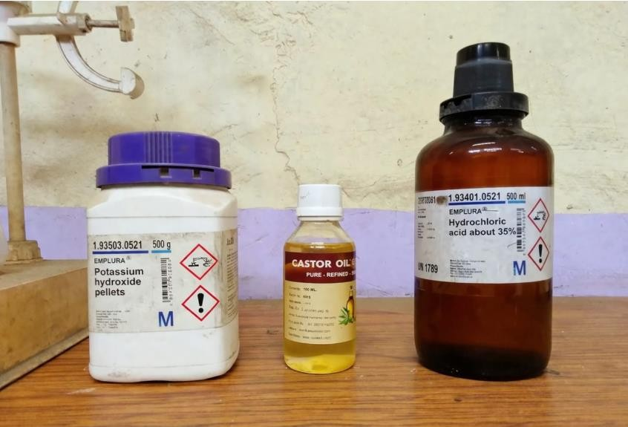
4

5

|

P

a

g

e

Introduction

Green detergents are environmentally friendly cleaning agents
prepared

from

renewable

natural

resources.

In

this

project,

oil

obtained
from Castor seeds is used as the primary raw material. Castor oil
contains

fatty

acids

which

can

be

converted

into

surfactants

suitable

for
detergent production.


6

|

P

a

g

e

The

project

involves

several

chemical

processes:

Refining

&

Degumming

–

Removal

of

impurities

using

boiling

water.
Saponification
–

Oil reacts with KOH to form soap.

Titration
–

HCl is used to determine saponification value.
Sulphation

–

Converts

fatty

alcohol

into

active

detergent

surfactant.
Neutralization
–

Adjusts pH to safe level.

Methodology / Procedure
1)Take 50 ml castor oil in a beaker and heat it to 50–60°C.
2)Prepare KOH solution by dissolving 8 g KOH in 50 ml distilled water. 3)Add KOH solution slowly into heated oil with continuous stirring. 4)Continue stirring for 30–40 minutes until saponification completes. 5)Add warm distilled water (50–80 ml) to adjust consistency.
6)Check pH and add dilute HCl dropwise to adjust pH near neutral. 7)Add fragrance and mix well to obtain liquid detergent
7

Module 1: Oil Refining and Degumming
Crude oil contains gums and impurities. It is treated with boiling water to remove these unwanted substances. The impurities settle down and refined oil is separated.
Module 2: Determination of Saponification Value
The refined oil is boiled with alcoholic KOH (Potassium Hydroxide). The excess KOH is titrated with HCl (Hydrochloric Acid). The saponification value is calculated to determine the amount of alkali required for detergent production.
Module 3: Sulphation Process
The oil or fatty matter undergoes sulphation using a sulphating agent. This converts fatty compounds into active surfactant material which improves cleaning ability.
Module 4: Neutralization
After sulphation, the product is acidic. It is neutralized using alkali to maintain proper pH suitable for detergent use.
Module 5: Bleaching and Perfuming
Bleaching is done to improve the color and appearance of detergent. Perfume is added to provide pleasant fragrance and consumer acceptance.

8

6. Applications

- Used for washing clothes and removing dirt effectively.
- Used for cleaning utensils and kitchen surfaces.
- Suitable for general household cleaning purposes.
- Can be used for cleaning floors and tiles

7.Advantages

- Eco-friendly and biodegradable, made from natural sources like Castor.
- Safe for skin and less harmful compared to synthetic detergents.
- Produces less pollution and is environmentally safe.
- Easy to prepare and economical.

8.Limitations

- Higher production cost
•Handling risk
- Time-consuming process
- Lower foam than synthetic detergents
- Shorter shelf life

G

9.Project Emissions / Environmental Impact

- Introduction
The manufacture of green detergent from castor oil at laboratory scale has lower environmental impact compared to synthetic detergents made from petroleum. Castor oil is a natural and renewable raw material obtained from the castor plant. However, even at small scale, the process still affects the environment in some ways.
- Impact on Air
During heating and mixing in the laboratory:
  - Small amounts of carbon dioxide (CO₂) may be released from electricity or gas use.
  - Minor chemical vapors may come from heating oils or other ingredients.
- Environmental Effect:
  - CO₂ contributes to global warming.
  - Vapors may reduce indoor air quality if ventilation is poor.
Since production is done at laboratory scale, the air impact is very low.
- Impact on Water
Water is used for washing, cleaning, and sometimes during the reaction process.
Wastewater may contain:
  - Soap and surfactants
  - Small amounts of unreacted oil
  - Alkali or other chemicals

10 | P a g e

Environmental Effect:
- High soap content can cause foaming in rivers.
- High organic matter can reduce oxygen in water, which can harm fish.
- Strong acids or bases can disturb water pH.
Proper treatment before disposal reduces this impact.
- Impact on Soil
Solid wastes such as:
  - Leftover oil
  - Filter paper
  - Packaging materials
If not disposed properly, they may cause soil pollution. However, because castor oil is biodegradable, the soil impact is generally low.
- Resource Consumption Impact
✯Raw Material
  - Castor oil is renewable and biodegradable.
  - It has lower environmental impact than petroleum-based chemicals.
✯Energy
  - Electricity or gas is needed for heating.
  - Energy use contributes to carbon emissions.
✯Water
  - Moderate water use may affect water resources if not managed well.

11 | P a g e

- Positive Environmental Impacts
  - Use of renewable raw material (castor oil).
  - Biodegradable final product.
  - Reduced dependence on petroleum.
  - Lower toxicity compared to synthetic detergents.
- Overall Environmental Impact
At laboratory scale, the environmental impact is low and manageable. Main impacts include:
  - Small air emissions
  - Wastewater generation
  - Minor solid waste
With proper waste treatment, ventilation, and responsible disposal, the process is environmentally friendly and supports green chemistry principles.
  - Minimal air pollution
  - Wastewater is biodegradable
  - Promotes green chemistry principles

12 | P a g e

Subtopic – Shaving Cream on Labscale

2.Abstract

This project deals with the preparation of shaving cream using natural oils such as Castor and Coconut through the process of saponification followed by mixing and emulsification. In this method, oils react with potassium hydroxide to form a soft soap base, which is then blended with glycerin and other additives to obtain a smooth and stable cream. The prepared shaving cream helps in softening facial hair, providing lubrication, and producing foam for easy and safe shaving. The product is economical, easy to prepare, and skin-friendly when compared to commercial shaving creams. This project demonstrates the application of basic chemical processes in the preparation of a useful cosmetic product.

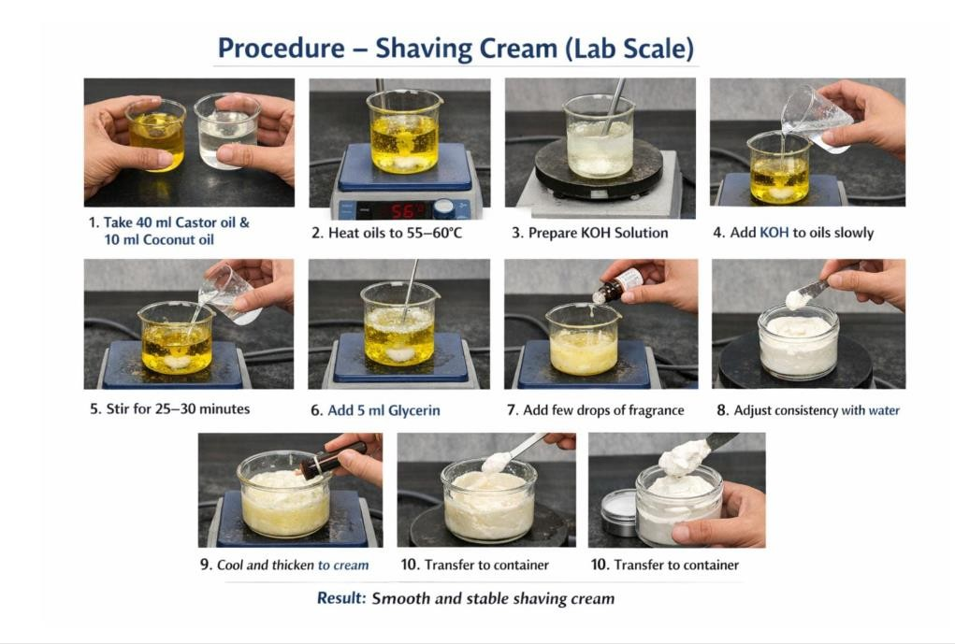

3.Introduction

Shaving cream is a cosmetic product used to soften facial hair and provide lubrication during shaving, which helps in reducing friction between the razor and the skin. It forms a smooth layer or foam on the skin that allows the razor to glide easily, thereby preventing cuts, irritation, and dryness. Shaving creams are generally prepared using natural oils such as Castor and Coconut, which are reacted with alkali like potassium hydroxide through the process of saponification to form a soft soap base. Additional components like glycerin are added to improve moisture retention and texture, while fragrances are used for pleasant smell. The use of natural ingredients makes the shaving cream safer for the skin and environmentally friendly compared to synthetic products. This project focuses on the preparation of shaving cream using simple laboratory methods and understanding its formulation and properties.

4.The project involves several chemical processes

The preparation of shaving cream involves important chemical processes such as saponification, emulsification, and mixing.
In the saponification process, natural oils such as Castor and Coconut react with potassium hydroxide (KOH) to form potassium soap, which acts as the base of shaving cream. This soap provides cleansing action and helps in producing foam. The emulsification process helps in forming a stable mixture of oil and water phases, giving the cream a smooth and uniform texture. Glycerin is added to improve moisture retention and provide a soft feel to the skin. Proper mixing and controlled heating ensure uniform consistency and stability of the final product. These combined processes result in a smooth, stable, and effective shaving cream suitable for safe and comfortable shaving.

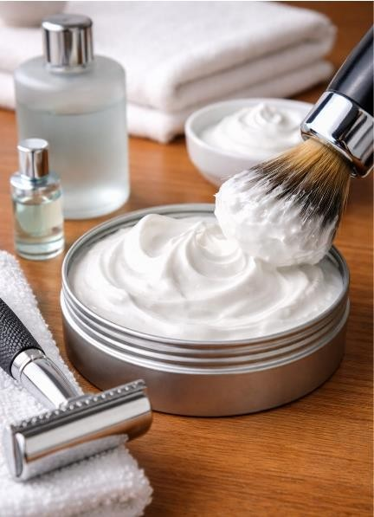

5. Methodology / Procedure

- Take 40 ml castor oil + 10 ml coconut oil in a beaker.
- Heat mixture to 55–60°C.
- Prepare KOH solution by dissolving 6–8 g KOH in 40 ml water.
- Add KOH solution slowly with continuous stirring.
- Stir for 30 minutes until cream forms.
- Add 5 ml glycerin for smoothness.
- Add fragrance and mix well.
- Adjust consistency using warm water if needed.

6. Applications

1.Shaving cream is used to soften facial hair and make shaving easier and smoother.
2.It provides lubrication between the razor and skin, reducing friction and preventing cuts and irritation.
3.It forms a protective foam layer that helps in safe and comfortable shaving.
4.It helps in moisturizing and hydrating the skin due to oils such as Castor and Coconut.
5.It is widely used in homes as well as in salons and barber shops for personal grooming purposes.

7. Advantages

- Smooth texture, moisturizing, easy to prepare.
- Provides smooth shaving
- Softens hair
- Reduces cuts and irritation
- Moisturizes skin (due to oils like Coconut)
- Easy to prepare

8. Limitations

- Less foam and stability issues.
- Short shelf life
- May have stability issues
- Needs proper pH control

9. Project Emissions / Environmental Impact

The preparation of shaving cream using natural oils such as Castor and Coconut has low environmental impact as it involves biodegradable materials and simple processes like saponification. The experiment produces very minimal emissions, mainly mild vapors during heating, and generates limited waste which can be safely disposed of after treatment. Overall, the product is eco-friendly and contributes less to environmental pollution compared to synthetic alternatives.

Subtopic – Leather Polish on Labscale

2. Abstract
The project deals with the preparation of leather polish on a laboratory scale using Castor oil as the main raw material along with wax through simple processes such as melting, mixing, and cooling. In this method, wax is heated until it melts and then blended with castor oil to form a uniform mixture, after which color and fragrance are added to improve the appearance and usability of the product. The prepared leather polish is used to provide shine, protection, and enhanced durability to leather items such as shoes and bags by forming a protective layer on the surface. The product is economical, easy to prepare, and effective in maintaining the quality and life of leather materials, demonstrating the practical application of basic formulation techniques in developing a useful and eco-friendly product.

3. Introduction
Leather polish is a product used to maintain, protect, and enhance the appearance of leather items such as shoes, bags, and belts by providing shine and improving durability. Leather materials tend to dry, crack, and lose their natural shine over time due to exposure to air, dust, and moisture, therefore regular polishing is essential to preserve their quality. In this project, leather polish is prepared using natural oil such as Castor along with wax, which helps in forming a protective coating on the leather surface.

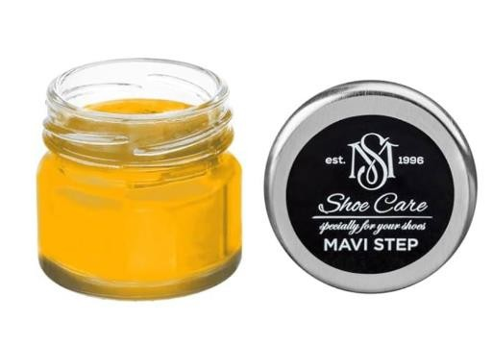

4.The project involves several chemical processes

The preparation of leather polish involves processes such as melting of wax, mixing with oil such as Castor, and cooling to form a semi-solid product, where heating ensures proper blending and uniform consistency of the mixture.

5. Methodology / Procedure

- Take 10 ml castor oil in a beaker.
- Add 5 g wax (beeswax/paraffin).
- Heat mixture at 60–70°C until wax melts.
- Stir continuously to obtain uniform mixture.
- Add color and fragrance.
- Pour into container and allow to cool

6. Applications

- Used for polishing shoes, bags, and leather items.
- Leather polish is used to provide shine and protection to leather items such as shoes, bags, and belts, and helps in maintaining their appearance and durability.

7. Advantages
- Improves shine and protects leather.
- Improves shine and appearance of leather
- Protects leather from drying and cracking
- Increases life of leather products
- Easy and economical to prepare

8. Limitations
- Melts at high temperature.
- May melt at high temperature
- Needs proper storage
- Excess use can make surface sticky

9. Project Emissions / Environmental Impact

The preparation of leather polish using oil such as Castor and wax has low environmental impact as it involves simple processes like melting and mixing with minimal emissions. Only slight vapors may be produced during heating, and the waste generated is very small and can be safely handled. Since natural materials are used, the final product is eco-friendly and does not cause significant environmental pollution.

22 | P a g e

10.Conclusion

The green detergent, shaving cream, and leather polish were successfully prepared using natural raw materials such as Castor oil and Coconut oil through simple laboratory processes like saponification, mixing, and melting. The green detergent showed effective cleaning action while being ecofriendly and biodegradable, the shaving cream provided smooth texture, adequate foam, and skin protection for comfortable shaving, and the leather polish offered good shine, protection, and improved durability to leather products. Overall, all the products were found to be economical, easy to prepare, and environmentally safe, demonstrating the practical application of basic chemical processes in developing useful household and cosmetic products



23 | P a g e

11.Project Initiation

This project was initiated with the aim of preparing eco-friendly and economical products such as green detergent, shaving cream, and leather polish using natural raw materials like Castor oil and Coconut oil. The objective was to understand and apply basic chemical processes such as saponification, neutralization, melting, and mixing at laboratory scale while reducing the use of harmful synthetic chemicals. The project also focuses on promoting green chemistry, environmental safety, and practical knowledge in formulation of useful household and cosmetic products.
24 | P a g e

12. Reference

- Paul Anastas and John C. Warner, Green Chemistry: Theory and Practice, Oxford University Press.
- McCabe, W.L., Smith, J.C., and Harriott, P., Unit Operations of Chemical Engineering, McGraw Hill.
- Kirk-Othmer Encyclopedia of Chemical Technology, “Soaps and Detergents” Section.
- Perry, R.H. and Green, D.W., Perry’s Chemical Engineers’ Handbook, McGraw Hill.
- Research articles on biodegradable surfactants and vegetable oil- based detergents (various journals of environmental and chemical engineering).
- Bajah S. T., Teibo B. O., Onwu G., Obikwere A., Senior Secondary Chemistry, Longman Publication, Lagos, Nigeria, pp. 153-156, 1995.
- George T. A., Shreve’s Chemical Process Industries, 5th ed. McGraw-Hill Book Company, New York, pp. 529, 1984.
- Isah A. G., Mohammed A., Garba M. U., Production, Refining and Evaluation of Castor Oil, Proceedings of 6th Annual Engineering Conference, School of Engineering Technology, Federal University of Technology, Minna, Nigeria, 15th - 17th June 2005, p. 50-56, 2005.
- Odigure J. O., Safety, Loss and Pollution Prevention in Chemical process Industries, Jodigs Associates Publication, Minna, Nigeria, pp. 89, 1998.
- How Does Soap Clean? [online]. ©2006 About. Available at: www.chemistry.about.com/library/weekly/aa081301a.htm .

25 | P a g e

